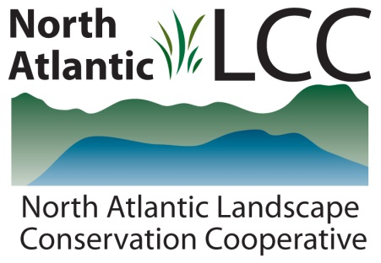

Connecticut River Watershed Landscape Conservation Design Pilot

Project Name | Designing Sustainable Landscapes – Landscape Capability Datasets for Representative Species of Wildlife
Product Type | GIS datasets that depict the capability of habitats across the northeastern U.S. to support a set of representative wildlife species
Product Description | The datasets depict the potential capability of the landscape throughout the northeastern United States to provide habitat for a set of representative wildlife species based on both current conditions and scenarios of potential future conditions. Future conditions include scenarios of future climate, urban growth (development), and forest change. The products include datasets that depict areas where the distribution of the species may expand, contract, or persist due to future landscape change.  The species were selected to represent a broad set of wildlife and associated ecosystems that collectively encompass a majority of the terrestrial, wetland, and coastal ecosystems of the Northeast. 30 species models will be completed by June 2014. Species being assessed include birds (such as Ruffed Grouse and Wood Duck), mammals (including Black Bear and Moose), and reptiles (such as Eastern Box Turtle and Diamond-backed Terrapin).  When field survey data are available for the species, the landscape capability datasets represent the integration of three models:  - A habitat capability model that reflects the quantity, quality, and accessibility of habitat across the landscape.  - A climate niche model based on analysis of climate conditions most suitable for the species (incorporates survey data)  - A prevalence model that reflects broad biogeographic factors about where the species occur (incorporates survey data)
Geographic Extent and data scale | The geographic extent is the region covered by the thirteen northeastern states. The resolution is 30 m cells.
Developer | Department of Environmental Conservation  University of Massachusetts Amherst
Contact | Professor Kevin McGarigal
Completion | 2014

Example landscape capability dataset: Wood Thrush, circa 2010 conditions
